**LAB ASSIGNMENT #2**

**(a)**

**STATEMENT:** WRITE A PROGRAM TO FIND TRANSPOSE MATRIX OF ANY 3*3 MATRIX.

**ALGORITHM:**

Step-1: Start

Step-2: Declare and input any 3*3 matrix.

Step-3: Interchange row into column and column into row.

Step-4: Print the transposed matrix.

Step-5: End

**SOURCE CODE:**

#include<stdio.h>

#include<conio.h>

void main()

{

clrscr();

int x[3][3],r,c;

printf("\n Input X-matrix: \n");

for(r=0;r<3;r++)

{

for(c=0;c<3;c++)

{

scanf("%d",&x[r][c]);

}

}

printf("\n The transpose of the X-matrix is: \n");

for(r=0;r<3;r++)

{

for(c=0;c<3;c++)

{

printf("\t %d",x[c][r]);

}

printf("\n");

}

getch();

}

**OUTPUT:**

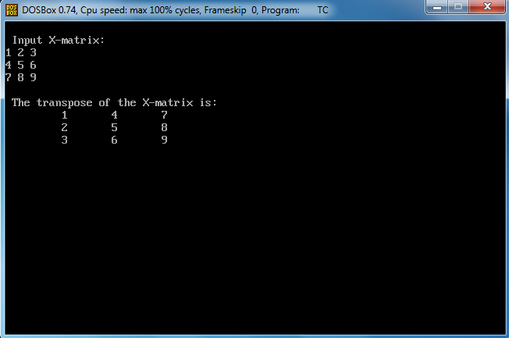

**CONCLUSION:** Hence, the program was successful, and the transpose matrix of a 3*3 matrix was found.

**(b)**

**STATEMENT:** WRITE A PROGRAM TO STORE AND CALCULATE PERCENTAGE AND RANK OF 5 SUBJECTS OF 10 STUDENTS.

**ALGORITHM:**

Step-1: Start

Step-2: Declare any 5 subjects, name, roll no. and percent.

Step-3: Input the name, roll no. and marks obtained in the 5 subjects by 10 students.

Step-4: Insert the formulae:

Percent = sum of marks in 5 subjects/5

Step-5: Print rank, name, roll no. and percentage.

Step-6: End.

**SOURCE CODE:**

#include<stdio.h>

#include<conio.h>

typedef struct

{

int maths;

int chem;

int phy;

int eng;

int comp;

}marks;

typedef struct

{

char name[10];

int rn;

marks sub;

float percent;

}record;

record std[10],temp;

void main()

{

clrscr();

void input(void);

void output(void);

input();

output();

getch();

}

void input(void)

{

int i;

printf("\n Input the marks record of 10 students: \n");

for(i=0;i<10;i++)

{

printf("\n Enter Name: ");

scanf("%s",std[i].name);

printf("\n Enter Roll No: ");

scanf("%d",&std[i].rn);

printf("\n Enter marks in: ");

printf("\n Physics: ");

scanf("%d",&std[i].sub.phy);

printf("\n Maths:");

scanf("%d",&std[i].sub.maths);

printf("\n Chemistry: ");

scanf("%d",&std[i].sub.chem);

printf("\n English: ");

scanf("%d",&std[i].sub.eng);

printf("\n Enter Computer: ");

scanf("%d",&std[i].sub.comp);

printf("\n *********************** \n\n");

}

}

void output(void)

{

int i,j;

for(i=0;i<10;i++)

{ std[i].percent=(std[i].sub.phy+std[i].sub.maths+std[i].sub.chem+std[i].sub.eng+std[i].sub.comp)/5;

}

for(i=1;i<10;i++)

{

for(j=0;j<9;j++)

{

if(std[j].percent<std[j+1].percent)

{

temp=std[j];

std[j]=std[j+1];

std[j+1]=temp;

}

}

}

for(i=0;i<10;i++)

{

printf("\n Rank : %d",i+1);

printf("\n Name : %s",std[i].name);

printf("\n Roll No : %d",std[i].rn);

printf("\n Percentage: %f",std[i].percent);

printf("\n ********************** \n\n");

}

}

**OUTPUT:**

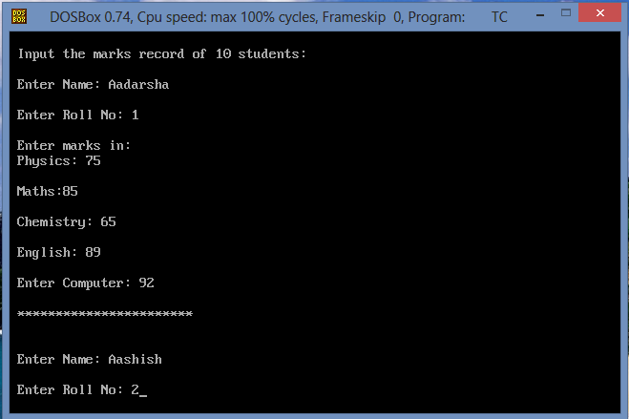

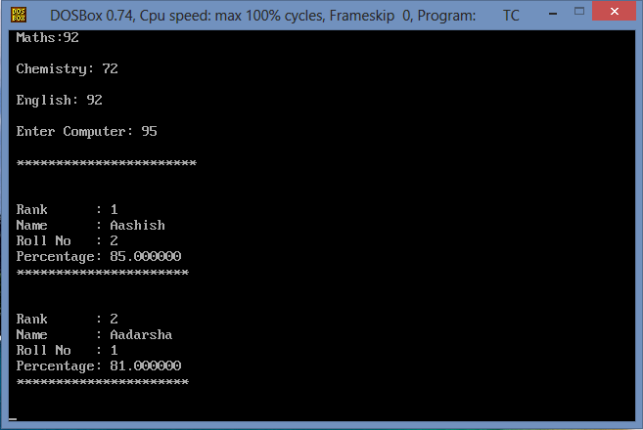

**CONCLUSION:** Hence, the program was successful, and the percentage and rank of 5 subjects of 10 students were calculated and stored.